AuraSTRX

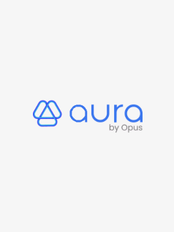
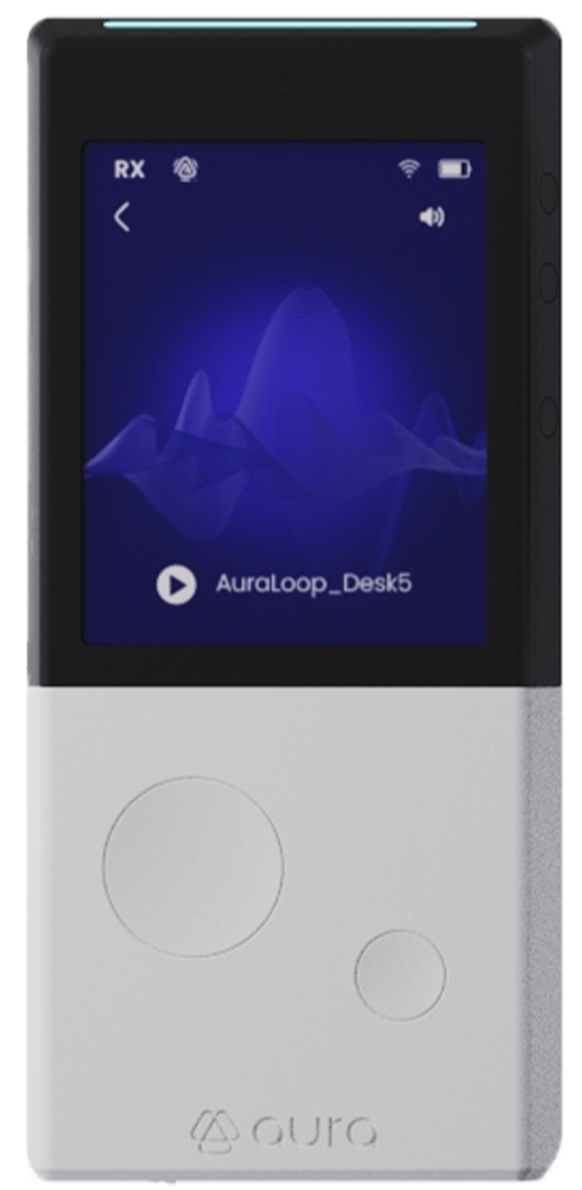
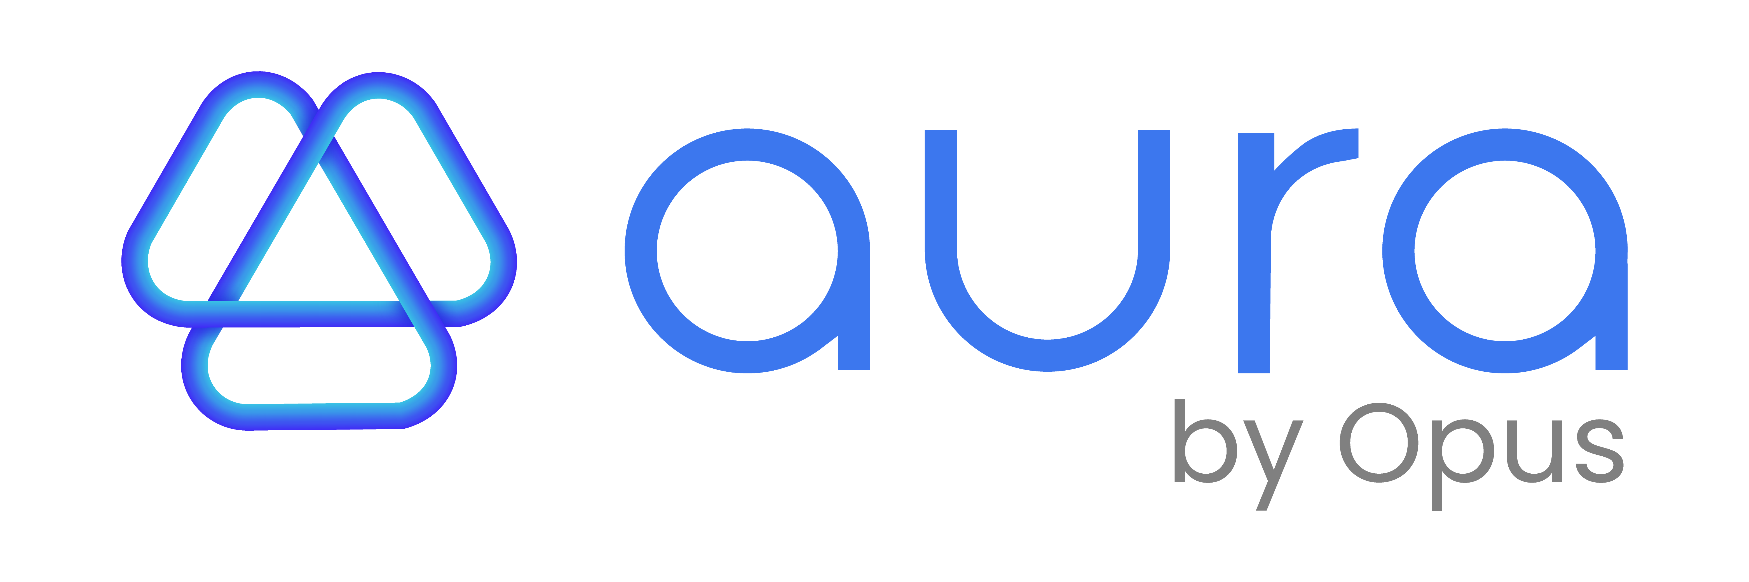

User Interface Guide v1.0.0

Table of contents
Overview 3
Part 1 — Quick Start: Listen now 4
Part 2 — Change the language 5
Part 3 — Start, pause, or resume a stream 5
Part 4 — Choose or switch broadcast (open or secured) 6
Part 5 — Connect to a secured broadcast (password or QR) 7
Part 7 — Events & System States (Consolidated) 8
Weak Signal 8
Disconnected 9
Volume Minimum 9
Transmitter Paused 9
Charging/Discharging 9
Low Battery (<10%) 10
Sleep 10
Deep Sleep 11
Troubleshooting (Quick Answers) 11

Revision
Autor | Version | email | Date | Comment
Ulrich PARE | 1.0.0 | - | 28/08/2025 | First revision

Overview
AuraSTRX is a wireless audio stream receiver designed for quick, reliable listening in public or private spaces. The UI keeps key info visible: volume, battery (%), signal strength, and play/pause. Contextual alert banners appear when action is needed (weak signal, transmitter pause, volume minimum, connection issues).
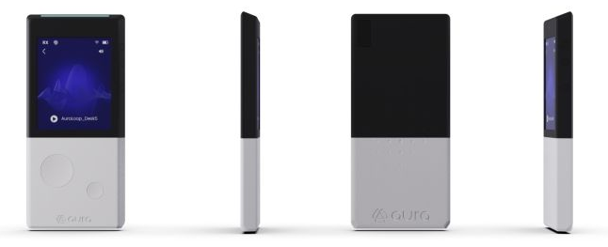
④
⑦
①

⑤

②
③

Figure – Overall UI
⑥

Marker | Description
① | Power button (short/long press)
② | Play/Pause
③ | Menu / Back
④/⑤ | Volume + / –
⑥ | USB-C port
⑦ | QR code module

Part 1 — Quick Start: Listen now
Goal: start listening to a nearby broadcast in under 30 seconds.
- Short‑press Power to turn on AuraSTRX.
- In the Stream List, highlight the desired broadcast (touch or press ③ (Menu) to navigate). And Confirm with a tap or press ② (Play/Pause).
- Tap on Play/Pause icon on the screen or press ② to start listening to the broadcast selected
Adjust volume with Volume ± on the side using ④/⑤ or use the slider on the screen to adapt it to your convenience.

Tips:
- The list is sorted by signal strength (strongest first).
- If a “lock” icon appears, see Part 5 to connect to secured broadcasts.
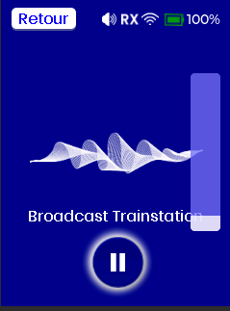
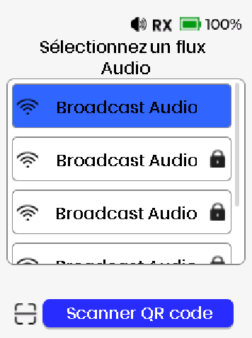
Volume up
④
Power on
Volume down

⑤
①

Select
②
Return to the Stream list
③

Play / Pause
③

②

Navigate

Figure – Quick Start

Part 2 — Change the language
Goal: switch UI language for labels and prompts.
1. From any screen, press and hold Menu + Play/Pause for ~1 second to open Language screen.
2. Select the desired language, FR / EN / ES (touch or press ③ to navigate).
3. Confirm with a tap or press ②.

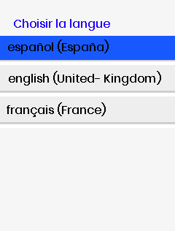

Select
Press together
②
②
Navigate
③

③

Figure – From any Screen → Language selection

Part 3 — Choose or switch broadcast (open or secured)
Goal: pick the right broadcast or change it during use.
1. Open the Stream List (③ from Any Screen except the Language screen).
2. Navigate through the panel to the desired broadcast by touch or ③ Menu button.
3. Confirm with a tap or ② (Play/Pause) to switch immediately.
4. If the broadcast is locked, the Identification screen will open (see Part 4).
Tips:
• Signal bars show expected quality; prefer stronger signals when possible.

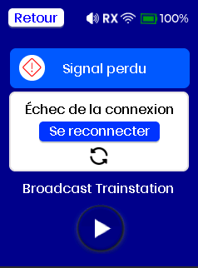
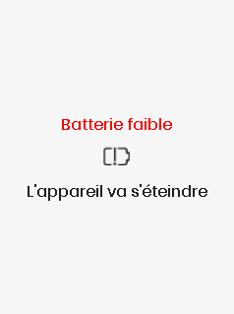

Select
②

Navigate
③

Return

③

Figure – Any Screen to Stream list with signal bars and lock icons

Part 4 — Connect to a secured broadcast (password or QR)
Goal: access locked broadcasts safely and quickly.
1. On the Identification screen, either:
2. a) Enter the password via the on‑screen keyboard then tap on connect or press ②.
On success, a choice panel appears to save credentials or not. Confirm with a tap or ② for yes and ③ for no.
On failure, a short message appears; retry entering the password.

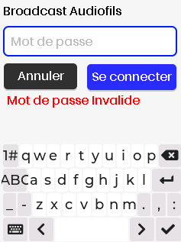
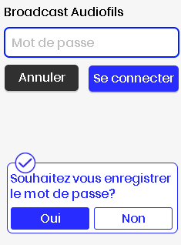
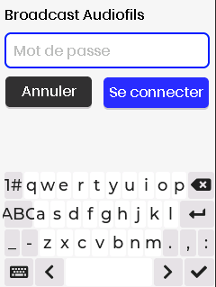

Or
Yes
②
Connect
②
No
③

Figure – Identification: Password entry

b) Select QR by taping on the screen button dedicated, aim the laser to the QR code. The scanner activates briefly.
On success, credentials are saved then the user is redirected to the Audio Screen. On failure, a short message appears; After 10 seconds aim the laser to the QR code to connect.
- If the password changes at the source, re‑enter or re‑scan the QR code.
- Recent credentials may be kept for convenience

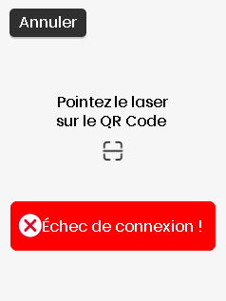
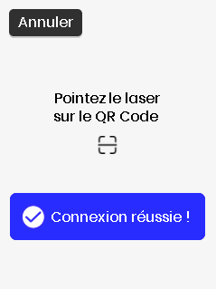

Or

Tap here

Figure – Identification: QR scan flow

Part 5 — Events & System States (Consolidated)

Weak Signal
Trigger/Condition: RSSI below threshold or unstable link.

What it means: Audio quality may degrade; risk of disconnect.
What to do:
1. Move closer to the transmitter; avoid walls/metal obstacles.
Figure – Alert banner — Weak signal

2. Hold device upright; keep clear line-of-sight if possible.
3. Consider switching to a stronger broadcast from the Stream List.

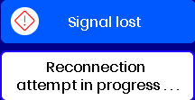

Disconnected
Trigger/Condition: Signal lost or authentication/session error.
What it means: The stream has stopped due to link loss or an error.
What to do:
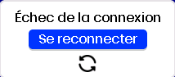
1. Wait for the auto-retry (a few seconds).
2. Tap Resync if offered.
3. If needed, open Stream List and reselect the broadcast.
Notes: If secured broadcast changed password, you’ll need to re-authenticate.
Figure – Alert banner — Disconnected

Volume Minimum

Trigger/Condition: Volume set to minimum or muted.
What it means: You won’t hear audio until volume is raised.
Figure – Alert banner — Volume minimum

What to do:
1. Press Volume + to raise the level.

Transmitter Paused

Trigger/Condition: Source/Auracast transmitter paused program.
What it means: Audio is intentionally paused upstream.
What to do:
Figure – Alert banner — Transmitter paused

1. Wait until the transmitter resumes.
2. Stay on the current broadcast or switch to another if needed.
Auto-recovery: Playback resumes automatically when source restarts.

Charging/Discharging
Trigger/Condition: USB power connected or not.
What it means: Battery is replenishing; device remains usable.
Figure – Charging/ Discharging overlay

What to do:
1. Keep connected until it reaches a comfortable charge level.
2. Avoid frequent very deep discharges for longevity.

Low Battery (<10%)
Trigger/Condition: Battery SoC drops below 10%.
What it means: Risk of shutdown; audio may stop unexpectedly.
What to do:
1. Connect USB power to charge.
2. Reduce screen-on time or enter Sleep to save power.
Auto-recovery: Returns to previous screen after 2 seconds.

Figure – Low Battery screen

Sleep
Trigger/Condition: Inactivity + accelerometer sensor conditions met.
What you see: Screen off; playback state preserved.
What it means: Power saving without full shutdown.
What to do:
1. Wake with movement or press any button (except Volume in some profiles).
2. Resume interaction on the current screen.
Auto-recovery: Auto-exits on wake conditions.
Notes: Estimated Autonomy > 1 week

Deep Sleep
Trigger/Condition: Extended inactivity with USB unplugged.
What you see: System unresponsive until wake action.
What it means: System off (no reception).
What to do:
1. Wake with movement or press any button.
2. Allow a few seconds for full system readiness.
Auto-recovery: No auto-exit; requires wake action.
Notes: Estimated Autonomy > 3 months

Troubleshooting (Quick Answers)
1. No sound → Check mute/volume; ensure stream is playing.
2. Unstable → Move closer or switch to stronger broadcast.
3. Password rejected → Re-enter with eye icon or re-scan QR.
4. Screen off → That’s Sleep; wake with movement + IR positive (<50cm) or a button.
5. Power off → Long-press Power (~3 s).
Aura by Opus distributed by Opus Technologies | 4 Allée Pierre-Gilles de Gennes | 33650 Martillac, France
(+33) 09 81 24 00 06 | hello@opus-technologies.fr | www.aurabyopus.com

